
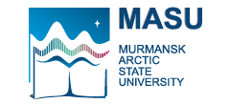

Ministry of Science and Higher Education of the Russian Federation

MURMANSK ARCTIC STATE UNIVERSITY

Kapitana Egorova 15, Murmansk, 183038 Теl. +7 8152 21 38 57 Fax: +7 8152 45 27 52
Е-mail: masu@masu.edu.ru www.masu.edu.ru
___________________________________________________________________________

TRANSCRIPT OF RECORDS

We certify that (name), born (date), is a student at Murmansk Arctic State University, (Institute/Faculty and department, see http://www.masu.edu.ru/en/about/campuses/ ) has completed all the courses below.

Name of the course | Grade | Credits

Dean of the Faculty
Mikhail Uksusov
Advisor of International Cooperation office

